CO2 Foodprint: Carbon Footprint Calculator

Members: Soma Badri (product owner), Riley Murphy, Destin Wong (scrum master), Raymond Lee, Kelley Broderick

Sprint Date: Weeks 4-6

Revision Number: 2

Revision Date: April 26, 2021

TA: yogolan@ucsc.edu

**Scale for Story Points**

1: X small

2: Small

3: Medium

5: Large

8: X Large

13: XXL

20/21: Huge

Sprint 2

|  |  |  |
| --- | --- | --- |
| Goal | Story Points | Priority |
| As a user, I want a place to input items in my recipe so that it can return the approximate carbon emission number of that item.   * Import edamam api (2 hrs) * Make it so you can input a food -> spit out nutrition facts (2 hrs) * Ask user for category (vegan, vegetarian, no red meat, average, meat lover) of each item->assign a score (1.5, 1.7, 1.9, 2.5, 3.3 respectively) (1 hr) | 20 | 1 |
| As a user, I want to have a login system so that I can set up an account with a user profile to customize for later   * Implement google authentication (1 hr) | 13 | 2 |
| As a user, I want the ability to add up multiple items so that it can return the approximate carbon emission number of an entire recipe.   * Create a counter for each category, divide by number of ingredients (1 hr) | 13 | 3 |
| As a user, I want the ability to have a score for emission use so I can strive for a more sustainable lifestyle and measure it numerically   * Save your recipe score to an overall user emission count (2 hrs) | 13 | 4 |
| As a user, I want the ability to input emission alternatives (such as riding bike instead of a car) so that I can track my emission use in/out   * Import berkeley api (1 hr) * Same idea as food but with minusing (2 hrs) | 8 | 5 |

Total ~ 12hrs

Initial Task assignment:

Riley: importing edam api

Destin: login, profile&calc page

Soma: diagram, landing&dashboard page

Raymond: material ui, login, navbar

Kelley: mongodb, profile&calc page

Burnup Chart: can't get rid of “points scored” sorry

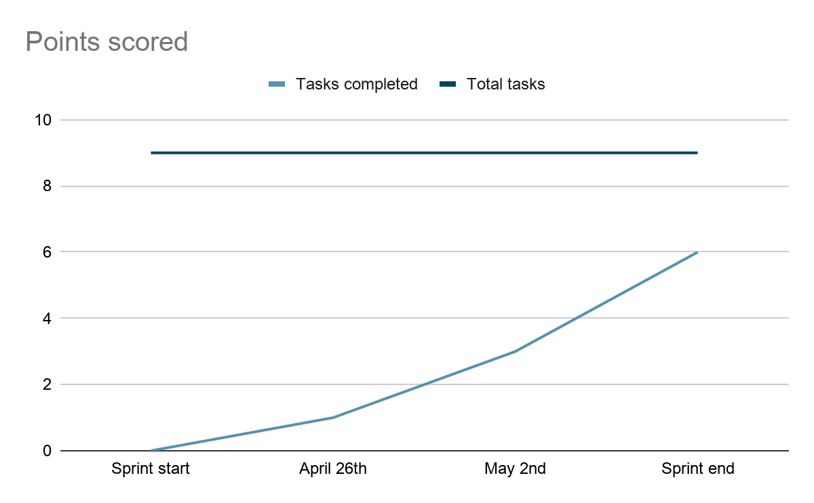

|  |  |  |  |
| --- | --- | --- | --- |
| Tasks | Not started | In progress | Complete |
| Import edamam api |  |  | x |
| Ask user for ingredients to make recipe |  |  | x |
| Ask user for category of food | x |  |  |
| Add up all ingredients |  |  | x |
| Google authentication |  |  | x |
| Counter for categories/num ingredients |  |  | x |
| Save recipe |  |  | x |
| Import berkeley api | x |  |  |
| Implement minus pts for good transportation | x |  |  |

Scrum board:

Sundays 1pm

Tuesdays 3-4 (with TA)

Thursdays 10:30am